PINEVILLE TELEPHONE BOARD, AGENDA 3:30 P.M.-PINEVILLE MEETING ROOM TOWN OF PINEVILLE, NORTH CAROLINA THURSDAY, JULY 28TH, 2022

- Minutes from April 28, 2022 Meeting.
- Fiber Neighborhood Service Stats
- Internet Growth FY22
- Internet Totals as of 7-25-2022
- Updates
- Future Meeting Dates
- Discuss plans for opening of new Town Hall

  - Minutes from 04-28-2022 Meeting
MINUTES OF THE

PINEVILLE TELEPHONE BOARD
HELD AT PCS BUILDING
118 COLLEGE ST, PINEVILLE, NC THURSDAY, APRIL 28, 2022
3:30 P.M.

The Telephone Board of the Town of Pineville, NC met on Thursday, April 28, 2022 at the PCS building, 118 College Street, Pineville, NC.

ATTENDANCE

Board Members: Mayor Pro Tem Ed Samaha, Les Gladden, Chris McDonough
Telecommunications Director: Tammy Vachon Town Clerk: Lisa Snyder
Absent: Mayor Edwards, Ryan Spitzer, Amelia Stinson-Wesley

CALL TO ORDER

Council Member Chris McDonough made a Motion to Open the meeting with a second made by Council Member Les Gladden. Motion approved and meeting opened at 3:30 pm.

Council member, Chris McDonough, called for a motion to approve the minutes of the September 23, 2021 meeting. Council Member Les Gladden seconded the motion. (Motion passed 4-0)

PCS Technician, Jason Williams, did a presentation on fiber connections for Council. He explained that one fiber will distribute service to 32 customers. It comes in different shapes, sizes and colors and is made with glass. Ms. Vachon included a diagram which shows how the fiber is brought to a home and what’s needed for the consumer to have active internet.

Ms. Vachon said that lines were built south of town with future developments in mind. If another company should hit our wires, they pay us. A landscaper had hit us in the Preston Park area and it cost them $15,000. Often you will find that other companies are on top of us. Having a conduit is another layer of protection for us so it is used to protect the fiber lines. Mr. Williams shared that the fiber can also go under water. A portable splicer is used to splice the wires on location and he gave a demonstration to Council.

Mayor Pro Tem asked how many lines are in his neighborhood at McCullough? Ms. Vachon replied that Time- Warner, Spectrum, AT&T, Pineville Communications, and there’s water, and gas.

In McCullough, fiber runs up to the box (ONT) outside of the house. In other areas, they run into the closets. If a renter has PCS, then move away, and the next resident does not go with PCS, they go out to that address and remove the box, thus saving several hundred dollars.

Ms. Vachon added that we are still having supply chain issues today. They are making deals and developing relationships with companies, and going with other companies, just to have their core items in stock. They have a lot of contract vendors that have helped them out many times since the supply shortages started.

The FCC is cracking down on multi-units, landlords, making exclusive right-to-serves. For example, Meadow Creek has an exclusive right-to-serve as part of their rent, per Ms. Vachon. She is hoping that legislation will say that you no longer have exclusive right-to-serve, so everybody has their own choice with regard to their services.

Fiber neighborhood stats. Ms. Vachon outlined take-rates. These are their fiber neighborhoods. Her department really hit hard to pick up the customer, highlighted in yellow, which includes Preston Park, Huntley Glen, Carolina Village, Chadwick Park and McCullough. We have 33% of Preston Park, which is going against Comporium and Spectrum, as well. She added that they are finding that “word of mouth” is really the best advertising for them, by talking to their neighbors.

Council Member McDonough asked if they can go to the HOA’s and try to sell to them? Ms. Vachon replied that they have tried that in the past, by going to their clubhouse and doing streaming demonstrations, and they continue to try to communicate with them. The residents have to call PCS to set up their utilities, so they try to take advantage of those calls as a selling opportunity and they also give them welcome packets to stay ahead of the game. There’s a multitude of things they try to do to capture that next customer.

Ms. Vachon stated that she does not ask for anything she doesn’t need and doesn’t buy unless we need it. They hunt for the best prices. She further stated that they are not supported by the taxpayer. They are supported by the money they make Programming is the largest expense for any television company and prices continue to increase. They like to have more money leftover so they have more to supplement plan under construction costs.

Mayor Pro Tem Samaha asked what plan under construction means? Ms. Vachon replied that it’s anything we’re building to, or building over. Areas that are owned by copper and we have to build fiber for, that is plan under construction. When the Miller property opens, you’re going to see a project cost and that’s a plan under
construction cost. How many feet of conduit do we need, how much fiber do we need, how many pedestals we’re going to set, that’s the cost to build. We only go in once curb and gutter is put in.

Ms. Vachon said that she thinks they offer something that no one else does. Their customer service is what they hang their hat on. They win customers from Spectrum and others because residents are tired of the experience they

were receiving from those companies. They also spend a lot of time educating their customers. They have to be better.

Internet growth. Ms. Vachon shared that they do everything they can to gain market-share. PCS saw a net growth of 556 internet subscribers between July 2021 to July 2022. They have tenured staff who really care and they want to keep going.

PCS Carrier of Last Resort. This means that per NC General Statute we are obligated to build facilities and serve areas within our ILEC. However, in our CLEC area we are not obligated to build or offer services because we are not the COLR in our CLEC area. Council Member Gladden added that he feels the best way to distinguish the
difference between ILEC and CLEC is that ILEC is the “inside the creeks” and CLEC is “outside the creeks.”

Cost Allocation Manual (CAM). The CAM serves two purposes. First, it’s the way the CLEC compensates the ILEC when staff is doing work in the CLEC area. Second, the CAM rates also would be charged to any competitor who wanted to co-locate in our central office. Ms. Vachon is looking to see if the CAM is actually needed anymore.

Updates. Ms. Vachon is making some changes to the monthly invoice and will now provide Electric customers a kilowatt usage graph that will appear on the back of their invoice. The graph will provide a 13-month history.

Shaken and Stir. This is defined by the FCC. It provides the basis to ensure authenticity of an IP phone call. Shaken stands for Secure Handling of Asserted Information using tokens and focuses on how STIR can be implemented with carriers’ networks.

Our PCS Rewards System. We look at what our competition is offering, bill stuffers, and websites, and make sure we are competitive. They used to give 10% discount off their gross portion of their electric bill, to residential customer, if they paid their bill on-time. They changed it to include internet. You can get a discount for each option that you add to your package. This has worked very well.

The next Telephone Board Meeting is scheduled for Thursday, July 28th at 3:30 at the PCS building.

There being no further items for discussion, Mayor Pro Tem Samaha made a motion to adjourn the meeting with a second made by Council Member McDonough. (Motion passed 4-0). Meeting adjourned at 5:10 p.m.

Telephone Board Chair

ATTEST:
Lisa Snyder, Town Clerk

Fiber Neighborhood Stats

McCullough Stats
Active Electric | 586
Active Electric No Internet | 270 | **Growth Potential**
Active Phone Lines | 26
Active Internet | 305 | **26 of these subscribers also have a phone line**
Active Internet & Phone | 26
Active Phone Only | 2
52% NEIGHBORHOOD TAKE
RATE
Carolina Village Stats
Active Electric | 157
Active Electric No Internet | 110 | **Growth Potential**
Active Phone Lines | 14
Active Internet | 47 | **9 of these subscribers also have phone line**
Active Internet & Phone | 9
Active Phone Only | 0
29% NEIGHBORHOOD TAKE
RATE
Chadwick Park
Active Electric | 101
Active Electric No Internet | 41 | **Growth Potential**
Active Phone Lines | 2
Active Internet | 60 | **2 of these subscribers also have a phone line**
Active Internet & Phone | 2
Active Phone Only | 0
59% NEIGHBORHOOD TAKE
RATE

Huntley Glen |  |  | **Growth Potential**
Active Electric | 230
Active Electric No Internet | 132
Active Phone Lines | 2
Active Internet | 98
Active Internet & Phone | 1
Active Phone Only | 1
42% NEIGHBORHOOD TAKE
RATE
Preston Park
Active Electric | 91
Active Electric No Internet | 102 |  |  | **Growth Potential**
Active Phone Lines | 2
Active Internet | 40 |  |  | **1 of these subscribers also have a phone line**
Active Internet & Phone | 2
Active Phone Only | 0
43% NEIGHBORHOOD TAKE RATE
Traditions
Active Electric |  | 157
Active Electric No Internet |  | 56 |  | **Growth Potential**
Active Phone Lines |  | 27
Active Internet |  | 90 |  | **26 of these subscribers also have a phone line**
Active Internet & Phone |  | 26
Active Phone Only |  | 12
53% NEIGHBORHOOD TAKE RATE

  - INTERNET GROWTH FY22

Month | Starting Subs | New Installs | Disconnects | Pending Installs for  following month | Pending Disconnects | Month Ending | Month Ending Subs | Net Gain/Loss
1-Jun-21 | 974 | 20 | -8 | 10 | 0 | 6/30/2021 | 996 | 22
1-Jul-21 | 996 | 26 | -10 | 6 | 0 | 7/31/2021 | 1019 | 23
1-Aug-21 | 1019 | 18 | -12 | 4 | 0 | 8/31/2021 | 1029 | 10
1-Sep-21 | 1029 | 24 | -13 | 10 | 0 | 9/30/2021 | 1050 | 21
1-Oct-21 | 1050 | 7 | -4 | 0 | 0 | 10/31/2021 | 1053 | 3
1-Nov-21 | 1053 | 14 | -7 | 0 | 0 | 11/30/2021 | 1060 | 7
1-Dec-21 | 1060 | 29 | -15 | 1 | 0 | 12/31/2021 | 1074 | 14
1-Jan-22 | 1074 | 27 | -8 | 0 | 0 | 1/31/2022 | 1093 | 19
1-Feb-22 | 1093 | 16 | -9 | 5 | 0 | 2/28/2022 | 1105 | 12
1-Mar-22 | 1105 | 20 | -19 | 0 | -3 | 3/31/2022 | 1103 | -2
1-Apr-22 | 1103 | 15 | -8 | 7 | 0 | 4/30/2022 | 1117 | 14
1-May-22 | 1117 | 16 | -8 | 0 | 0 | 5/31/2022 | 1125 | 8
1-Jun-22 | 1125 | 8 | -7 | 7 | 0 | 6/30/2022 | 1133 | 8
1-Jul-22 | 1133 |  |  |  |  | 7/31/2022
 | 137 | 220 | -120 | 40 | -3 | 137 | 137 | 137
13.7% NET GROWTH IN FY22
NET GAIN OF 137 SUBS IN FY22
260 INTERNET INSTALLATIONS COMPLETED IN FY22
123 INTERNET DISCONNECTS ENTERED IN FY22

FY21 ENDING SUBSCRIBER COUNT 996
FY22 STARTING SUBSCRIBER COUNT 996
FY22 ENDING SUBSCRIBER COUNT 1133

Internet Subs as of 7-25-2022

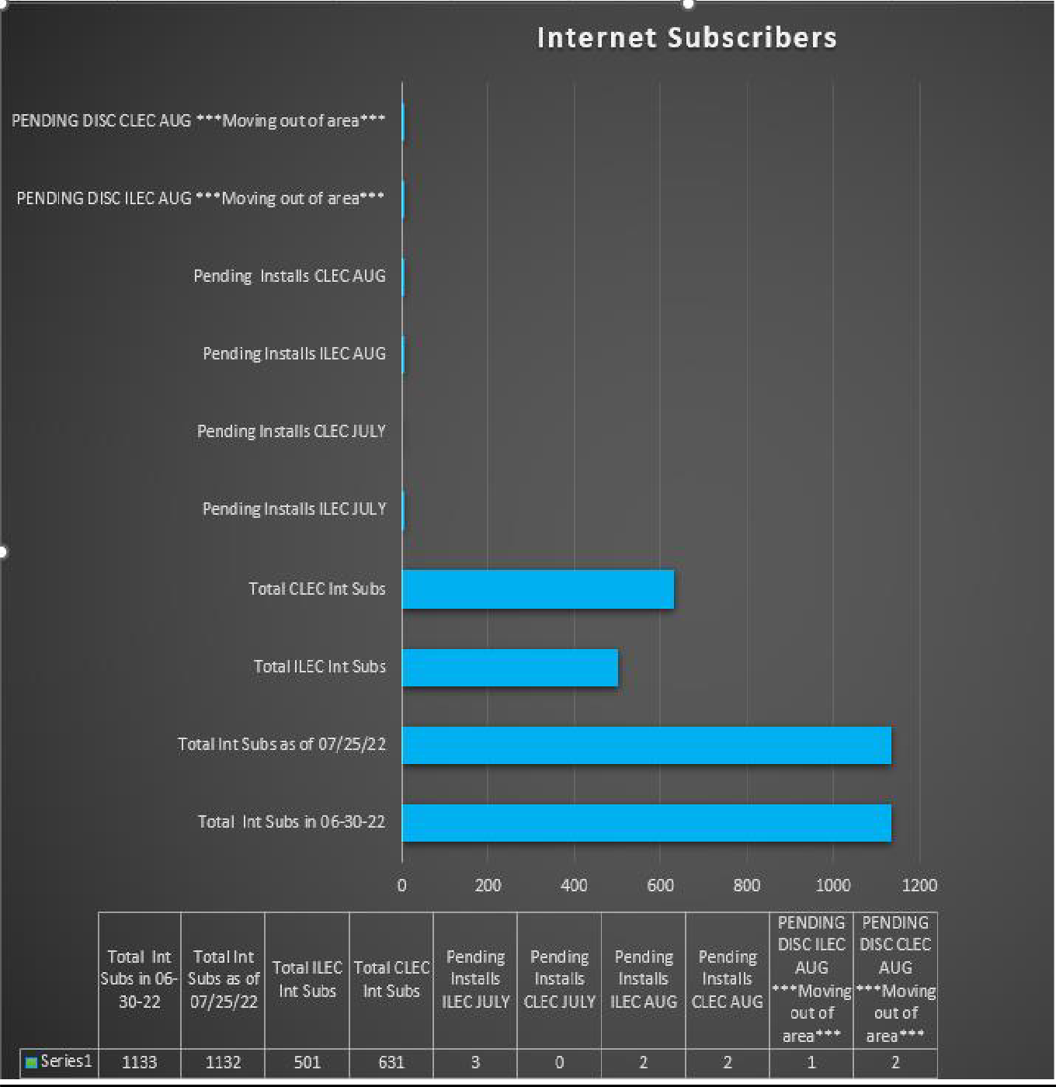

INTERNET SUBSCRIBERS AS OF 7-25-2022
Total Internet Subscribers (INCLUDES 3 pending orders) as of 7-25-2022 | 1035
Total CLEC Internet Subscribers as of 7-25-2022 | 631
Total ILEC Internet Subscribers as of 7-25-2022 | 501
Total Internet Subscribers as of 7-25-2022 | 1032
Total CLEC Internet Subscribers as of 7-25-2022 | 631
Total ILEC Internet Subscribers as of 7-25-2022 | 501
PENDING ILEC INSTALLS TO DATE | 2
PENDING CLEC INSTALLS TO DATE | 2
PENDING ILEC DISCONNECTS TO DATE | 1 | **
PENDING CLEC DISCONNECTS TO DATE | 2 | **
**MOVING OUT OF OUR SERVICE AREA**

  - DEPARTMENT UPDATES

I have filled two of my 3 vacant positions. Valarie Murphy was hired to fill the Electric Billing and Collection Coordinator role that was vacant from March when Kristen Mercer left and Brooke Smith was hired to fill my Part Time CSR role. We are still trying to fill the Systems Tech role.

Team is continuing to work projects associated with the Central Office relocation to the New Town Hall. When the TCO is issued and the elevator is working the racking will be brought into the new central office and we will begin installing the equipment bays, wire racking etc.

PCS has partnered with Parks N Rec for the summer concert series. Matt & his team have hand fans that they have available to attendees during the concerts and we have our company info and logo in addition to the Parks & Rec Rock’n & Reel’n info with bar code containing their summer concert schedule. PCS will also be sponsoring water stations during some of the concerts for attendees to have bottled water available to them at no charge.

In August I plan for the CSR’s to resume our after hours sales calls. We suspended this while the Billing and Collection Coordinator position was vacant. In addition now that the Part Time CSR role is filled this will allow us additional time during the day for the CSR’s to make additional sales calls during the regular business day while still providing phone .

  - Future Meeting Dates
October 27th, 2022 @ 3:30

