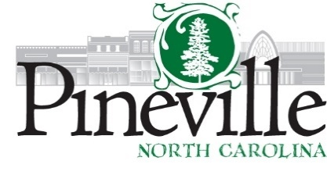
Town Council Regular Meeting
Pineville Hut Meeting Facility
Tuesday, May 11, 2021 AT 6:30 PM
Agenda
CALL TO ORDER
Pledge Allegiance to the Flag (MD)
Moment of Silence
ADOPTION OF AGENDA
APPROVAL OF THE MINUTES
1. Approval of the minutes from the Regular Council Meeting of April 13, 2021 and the Work Session Minutes of April 26, 2021
CONSENT AGENDA
2. Revenue and Finance Reports as of 4/30/21 (Richard Dixon)
PUBLIC COMMENT
PUBLIC HEARING
3. Public Hearing for FY 2021-2022 Budget (Ryan Spitzer) - Mr. Spitzer will present the upcoming fiscal year budget including Electric Reps and Riders and the town's fee schedule.
OLD BUSINESS
NEW BUSINESS
4. Discussion on Excess Revenue (Ryan Spitzer) Council to discuss what capital projects they would like to use that revenue for.
5. Project Budget for the Lakeview/Lynwood Storm Water Project (Richard Dixon) - A Project Budget will be presented to track expenditures for this project.
6. Resolution No. 2021-09 to Adopt Policy for Law Enforcement Mutual Aid Agreement (Chief Hudgins) -
STAFF UPDATE
7. Manager's Report/Staff Reports
8. Calendar of Events for May/June
CLOSED SESSION
ADJOURN

If you require any type of reasonable accommodation as a result of physical, sensory, or mental disability in order to participate in this meeting, please contact Barbara Monticello, Clerk of Council, at 704-889-2291 or bmonticello@pinevillenc.gov. Three days’ notice is required.

ZOOM MEETING INFORMATION:

Topic: May Council Meeting
Time: May 11, 2021 06:30 PM Eastern Time (US and Canada)
Join Zoom Meeting
https://us02web.zoom.us/j/87936795348?pwd=cnNpRzd0Yk53ZHVQeXVWOGRkUFVGZz09

Meeting ID: 879 3679 5348
Passcode: 091368
One tap mobile
+13017158592,,87936795348#,,,,*091368# US (Washington DC)
+13126266799,,87936795348#,,,,*091368# US (Chicago)

Dial by your location
+1 301 715 8592 US (Washington DC)
+1 312 626 6799 US (Chicago)
+1 646 558 8656 US (New York)
+1 253 215 8782 US (Tacoma)
+1 346 248 7799 US (Houston)
+1 669 900 9128 US (San Jose)
Meeting ID: 879 3679 5348
Passcode: 091368
Find your local number: https://us02web.zoom.us/u/kxROmSMI0

