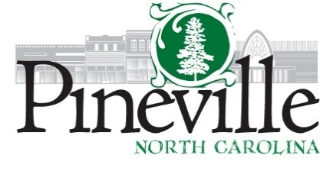
Town Council Regular Meeting
Pineville Hut Meeting Facility
Tuesday, September 08, 2020 AT 6:30 PM
Agenda
CALL TO ORDER:
CLOSED SESSION: First Closed Session to begin at 6:00 p.m. Discussion of matters pursuant to NCGS 143-318.11(3) to consult with attorney on possible legal action.
Pledge Allegiance to the Flag: (ASW)
Moment of Silence:
ADOPTION OF AGENDA:
APPROVAL OF THE MINUTES: Regular Council Meeting of August 11, 2020 and the Work Session of August 24, 2020
CONSENT AGENDA:
Financial Report as of 8/30/20
Proclamation for Constitution Week
PUBLIC COMMENT:
PUBLIC HEARING:
Public Hearing to Consider Renovations to Jiffy Lube Located on North Polk St. (Travis Morgan)
OLD BUSINESS:
NEW BUSINESS:
Council Vote on Jiffy Lube - (ACTION ITEM)
Resolution No. 2020-03 - A Supplemental Resolution Declaring Intent to Reimburse Expenditures with Proceeds of Debt Pursuant to US Department of Treasury Regulations (Richard Dixon) (ACTION ITEM).
Council Vote on Approval of Agreement for Bond Council (Richard Dixon) (ACTION ITEM).
STAFF UPDATE:
Manager and Staff Reports
Calendar of Events
CLOSED SESSION: Second Closed Session immediately following Regular Council Meeting for discussion of matters pursuant to NCGS 143-318.11(4) pertaining to Economic Development.
ADJOURN:

If you require any type of reasonable accommodation as a result of physical, sensory, or mental disability in order to participate in this meeting, please contact Barbara Monticello, Clerk of Council, at 704-889-2291 or bmonticello@pinevillenc.gov. Three days’ notice is required.

