NOTICE OF CONSTRUCTION
August 17th, 2023

Dear Property Owner:

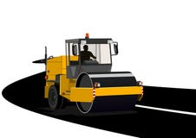
This notice is to inform you that Exceptional Development, LLC is commencing construction for full-depth pavement reclamation (FDR) for Lynnwood Lane and Lakeview Drive. Paving activities are scheduled to begin August 21st, 2023, with mobilization starting the week before. Existing pavement will be reclaimed, and new asphalt will be placed on your street. During the paving process, you will notice pavement markings, wooden survey stakes, traffic control signage, construction personnel, or other activities related to the project, as well as traffic pattern disruptions. You may also feel slight vibrations from the construction equipment, but this is no cause for concern.

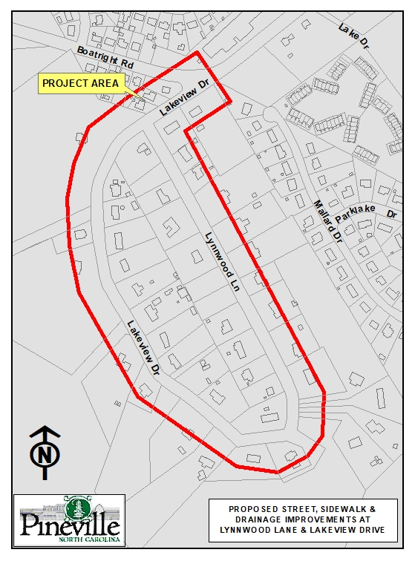
Along with the construction for FDR, new concrete driveway aprons will be poured. We ask that you do not drive or park on them for 72 hours after pouring to allow the concrete to cure. You will be asked to park away from your driveway for a short time. Please be assured that Labella and the Town will work closely with the contractor to minimize inconveniences as much as possible.Our construction inspector will communicate closely with each property owner as needed throughout this process.

Thank you for your cooperation and patience as this project comes to a close. If you have any questions about this project, please call Steve Canter, Inspector at 704-792-5610 or Bonnie Fisher, PE with LaBella Associates at 704-941-2132.
Sincerely,

Bonnie Fisher, PE
Project Manager
LaBella Associates

