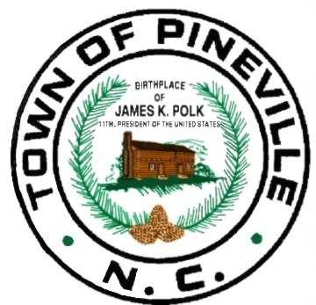
The Town of
Pineville
North Carolina
____________________________________________________________________________________
505 Main Street, Pineville, North Carolina 28134 * 704-889-2291

NOTICE IS HEREBY GIVEN
OF A SPECIAL CALLED MEETING
BY THE PINEVILLE TOWN COUNCIL
FOR TUESDAY, OCTOBER 17TH AT 5:00 PM
TO BE HELD AT THE PINEVILLE TOWN HALL COUNCIL CHAMBERS LOCATED AT 505 MAIN STREET, PINEVILLE, NC
THE PURPOSE OF THE MEETING IS TO HOLD A
CLOSED SESSION PURSUANT
TO §143-318.11(6)
TO DISCUSS A PERSONNEL ISSUE.

