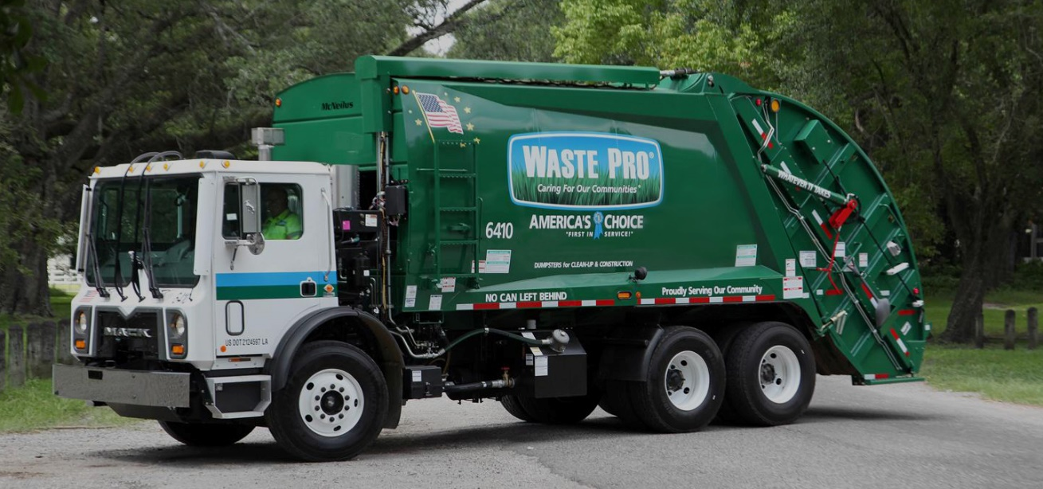

Waste Pro will not be running on Monday December 25th nor Monday January 1st. ALL routes will be collected on a one-day delay for two consecutive weeks,
beginning the week of December 25, 2023, and ending January 7, 2024.

BELOW IS EFFECTIVE FOR THE WEEKS OF: Monday, December 25, 2023, and Monday, January 7, 2024:

Monday routes will be collected Tuesday
Tuesday routes will be collected Wednesday
Wednesday routes will be collected Thursday
Thursday routes will be collected Friday
Friday routes will be collected Saturday.

