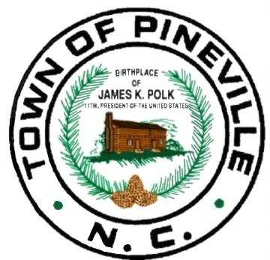

THE TOWN OF
PINEVILLE
NORTH CAROLINA
__________________________________________________________________

P O Box 249 * Pineville, North Carolina 28134 * (704) 889-2291 __________________________________________________________________

NOTICE IS HEREBY GIVEN OF A SPECIAL CALLED MEETING
BY THE PINEVILLE TOWN COUNCIL
FOR MONDAY, MARCH 25TH AT 7:30PM
TO BE HELD AT THE PINEVILLE TOWN HALL COUNCIL CHAMBERS LOCATED AT 505 MAIN STREET, PINEVILLE, NC.

THE PURPOSE OF THE MEETING IS TO VOTE ON THE LOCATION OF THE SUBSTATION WITHIN THE PINEVILLE TOWN LIMITS,
AND TO POSSIBLY VOTE ON A RESOLUTION TO ACQUIRE BY EMINENT DOMAIN OR ENTER INTO NEGOTIATIONS FOR PURCHASE OF PROPERTY IN ASSOCIATION WITH THE PROJECT.

A Small Town with Big Ideas!

