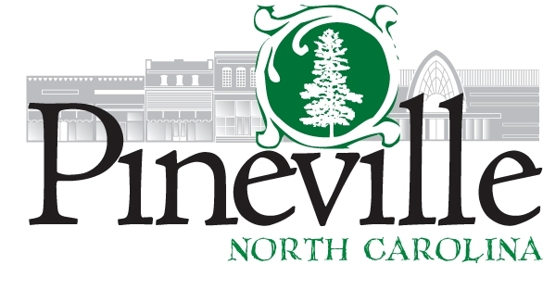

Community Relations and Communications Specialist

Department: Administration FLSA: Non-Exempt
Reports to: Town Manager

GENERAL DESCRIPTION
Under the general supervision of the Town Manager, this person performs professional work in developing and administering internal and external communication and programs for the Town that encourage open communication and civic and employee engagement. The Community Relations and Communications Specialist will manage and provide strategic leadership for the Town’s affairs and communication initiatives, oversee and execute marketing and communications efforts, and manage media and communication channels. This person serves as a conduit for the community and provides information to the public, media, and Town employees on programs, events, services and issues. The employee will be able to exercise considerable initiative, imagination and independent judgement to develop, coordinate, supervise and market a variety of events and activities within the community. The employee will also work to identify and complete grant funding opportunities. Work requires continuous contact with a variety of public officials, community leaders, media representatives, the general public, and internal Town program leaders. Work will be evaluated on the recognized success of communications programs, events, grants identified, and civic engagement.

ESSENTIAL JOB FUNCTIONS
Develop and maintain relationships with key community groups, external agencies and/or other interested parties.

Develop, coordinate, administer, oversee, and market the Town’s downtown and Main Street program with emphasis on the Four Point Approach

Direct the overall development, coordination, and execution of the Town’s comprehensive communications plan.

Act as the Town’s official spokesperson with the media, and direct media inquiries to the appropriate Town contact as needed.

Work with departments to proactively develop media and community relations and enhance employee engagement through writing, reviewing, and editing of news releases, newsletters, emails, article, posting, publications, scripts, etc.

Execute communication plans for various Town functions and events, both internally and externally through applicable resources, including social medica platforms.

Develop, manage, and coordinate all marketing, advertising, and promotional activiteis. Proactively promote the Town, it’s accomplishments and activities.

Develop and implement town incentive programs for businesses; assist businesses in obtaining state and local incentives.

Coordinate the economic development efforts of community groups. Serve as staff liasion to the business community

Serve on various boards and committees representing the Town and work non-traditional work hours to be present at various special events and meetings. May need to respond in the event of an emergency incident.

Locate grant funding opportunities relevant to the strategic goals of the Town. Assist departments with grant opportunities.

Plan, develop and promote event and program activities in the Town to include seasonal community outreach and programs

Acts as the Town’s official spokesperson with the media, and directs media inquiries to the appropriate Town contact as needed.

Develop and monitor events and program budgets, and assist with financial activities related to each event. This may include ticket sales, registrations, invoicing of fees, etc.

Help design the layout for events and coordinate with appropriate entities on any arrangements needed for public safety, street closures, public work’s needs, etc.

Proactively promote the town’s branding, accomplishments, and activities.

Observe and evaluate downtown events and program activities for quality, accuracy and impact on target audience. Assist with collections of event statistics.

Manage social media platforms and the town’s website

Responsible for scheduled email contact through mass email provider to merchants, volunteers, past and present event participants and Town staff with messaging to include upcoming events, street closures, etc.

Advise the Town Council and staff on policy and administrative matters regarding business attraction and retention.

Performs related duties as required.

KNOWLEDGE, SKILLS AND ABILITIES
Thorough knowledge of the principles and practices of public relations and related tools and techniques for building a positive image.
Thorough knowledge of public information and use of principles and practices of public relations media, print advertising, and social media platforms.
Thorough knowledge of NC public information laws.
Ability to develop public relations strategies and provide and provide consultation and assistance with communication.
Considerable knowledge of the principles, practices and policies of event and volunteer management.
Ability to effectively plan, promote, organize and execute a year-round program of events and program activities.
Ability to establish and maintain complex records, files and budgets.
Considerable skill in dealing with the public in high stress situations.
Ability to maintain working relationships while exercising tact and courtesy in frequent contact with professionals, public officials merchants, vendors, volunteers, and the general public.
Ability to perform research and to compile organize, analyze and present information in a variety of formats.
Ability to express ideas effectively in oral and written forms.
Working knowledge of common practices associated with locating grants and submitting applications.
Ability to solicit and secure sponsorships.
Demonstrated applied skills in social media and/or website editing.

EDUCATION AND EXPERIENCE
Graduation from a four-year college or university with a degree in communication, public relations, event management, or related field is required. Two years of communications or public relations experience required. Experience in either business development or event planning activities is desired, or an equivalent combination of education and experience.

ADDITIONAL REQUIREMENTS
Valid driver’s license.

PHYSICAL REQUIREMENTS
Must be able to physically perform the basic life functions of climbing, balancing, stooping, kneeling, crouching, crawling, reaching, standing, walking, pushing, pulling, lifting, fingering, grasping, feeling, talking, hearing, and performing repetitive motions.
Must be able to perform light work exerting up to 2 pounds of force occasionally; and/or up to 1 pounds of force frequently to move objects.
Must possess the visual acuity to prepare and analyze data, to read extensively, and to make visual inspections to determine accuracy neatness and thoroughness of work assigned.

Signed: _____________________

Print Name: _____________________

Date: _____________________

