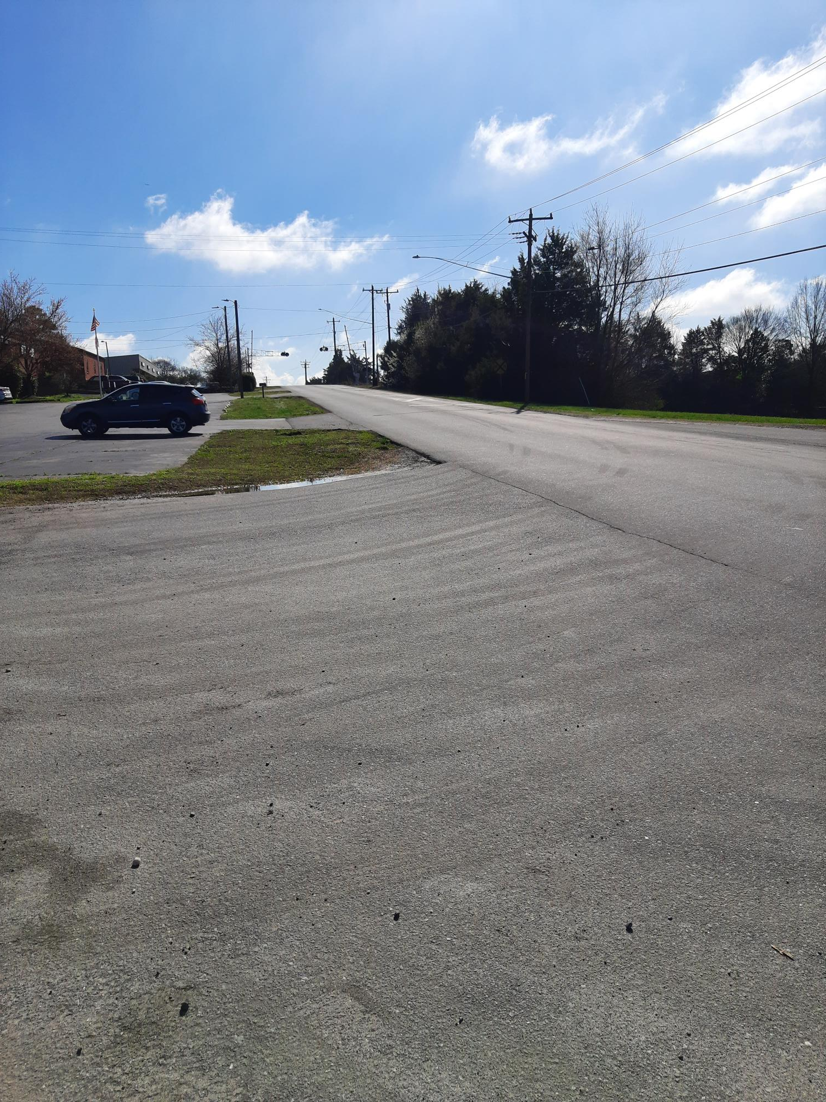

Paving of Industrial Drive: Work is scheduled to begin on April 25th, depending on the weather. The majority of work will be done on the weekend to minimize impact on traffic.

