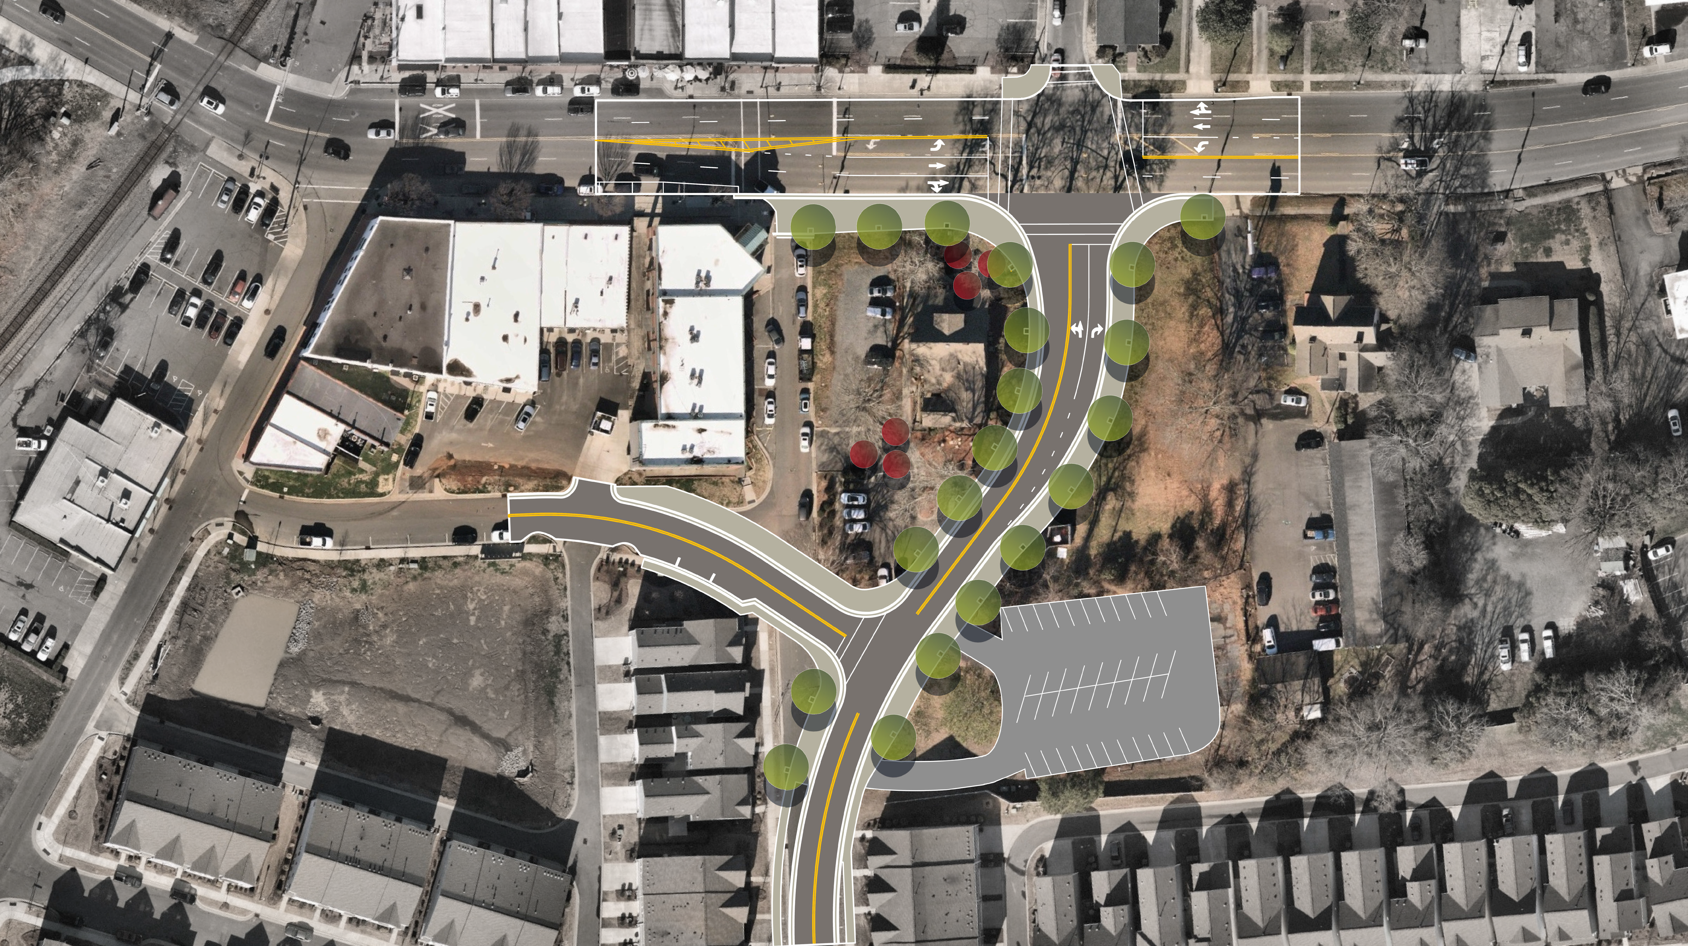

The Johnston Drive Alignment Project has begun. The construction schedule began in February and is scheduled for completion in June 2024.

