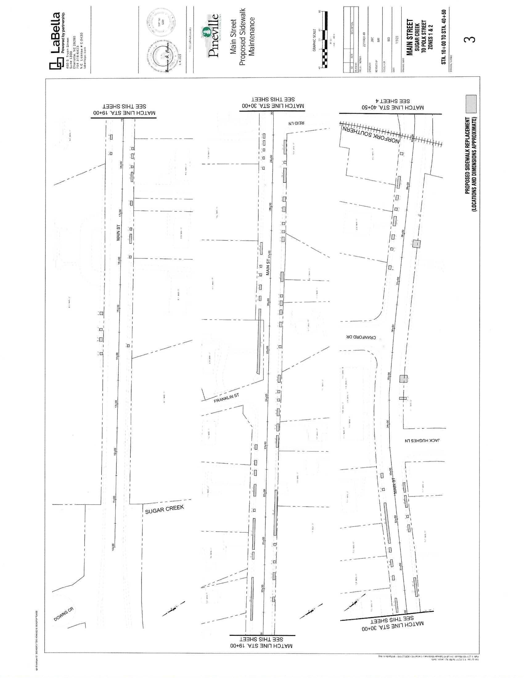
Sidewalks on South Side of Hwy 51: Work is scheduled to begin in May, depending on weather.

