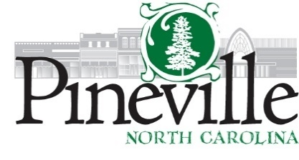
Work Session
Town Hall Council Chambers
Monday, August 25, 2025 AT 6:00 PM

AGENDA

CALL TO ORDER

DISCUSSION ITEMS
1. New Playground (Matt Jakubowski)
2. DRB CIAC Reduction (Ryan Spitzer)
3. HiLine Parking (Ryan Spitzer)
4. Cone Mill Project (Jon Visconti)
5. Polk Street Development for 606 N. Polk Street (Travis Morgan)
6. Town Logo Presentation (Riley George)

ADJOURN

